sql语句中有分组的，count是对每个组内进行计数的。

id是自增、主键，其他是一般字段

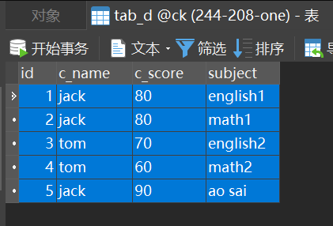

SELECT COUNT(*) FROM tab_d GROUP BY c_name; （符合预期）

//可知计数是对分组后每个组内进行的。

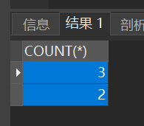

SELECT c_name,COUNT(*) FROM tab_d GROUP BY c_name;

（符合预期）

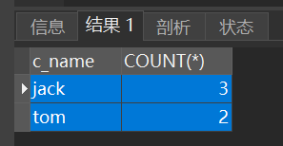

SELECT c_name,`subject`,COUNT(*) FROM tab_d GROUP BY c_name;

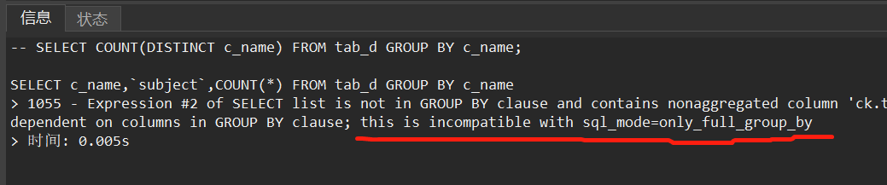

对JOIN表的带group by条件的含count的搜索，sql语句写法示例：

SELECT t_info.panel_id, COUNT(*) FROM t_info JOIN t_file ON t_info.id = t_file.resource_id WHERE t_resource_info.batch = 1 GROUP BY t_resource_info.panel_id;

**如果有分组，则COUNT必然是对分组后每个组内进行计数，而非是对组间的组个数计数。**

**不论sql中是否撑开组成员，也不论COUNT(*)中的*写成分组依据字段。**

=========证明1=========

原始表：

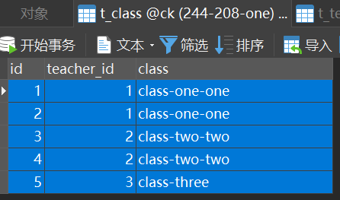

SELECT COUNT(*) FROM t_class GROUP BY teacher_id;

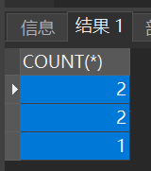

SELECT COUNT(teacher_id) FROM t_class GROUP BY teacher_id;

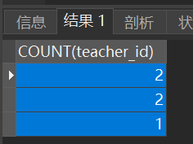

以上两种，无论如何写count，都不会计算得到组的个数3

=========证明2=========

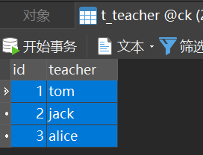



先看看联表后的情况

SELECT * FROM t_teacher INNER JOIN t_class ON t_class.teacher_id = t_teacher.id GROUP BY teacher, t_class.id ORDER BY t_teacher.id;

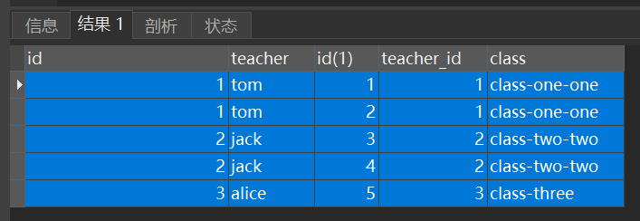

现在看分组计数

SELECT COUNT(*) FROM t_teacher INNER JOIN t_class ON t_teacher.id = t_class.teacher_id GROUP BY teacher ORDER BY t_teacher.id; 可见COUNT(*)默认就是对分组后每个组内的计数

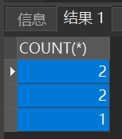

指明组内计数

SELECT COUNT(t_class.id) FROM t_teacher INNER JOIN t_class ON t_teacher.id = t_class.teacher_id GROUP BY teacher ORDER BY t_teacher.id;

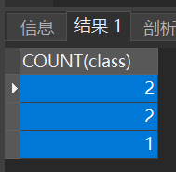

指明组间计数，即计算组数

SELECT COUNT(teacher) FROM t_teacher INNER JOIN t_class ON t_teacher.id = t_class.teacher_id GROUP BY teacher ORDER BY t_teacher.id;

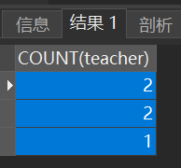 可见，实际仍是对分组后组内的计数，而不会得到组的个数3

要想获得分组后组的个数，可以不使用COUNT而直接使用len来对查询到的结果计数。

（完）